**Phase – II**

**Practice Project – III**

**Add New Product**

**Sai Krishna Rajagopal**

**22-03-2022**

1. Screenshots:

Index Jsp:

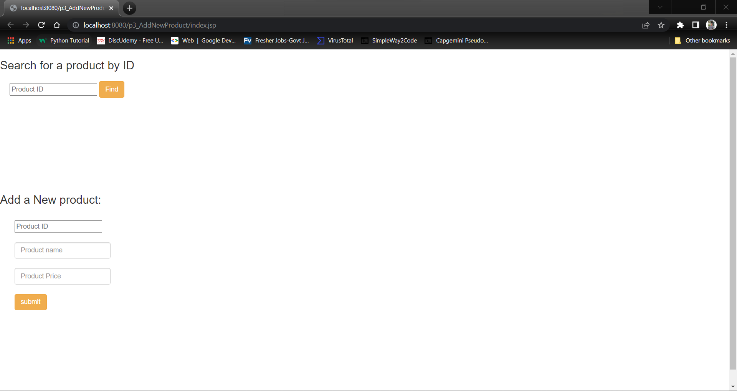

Output1:

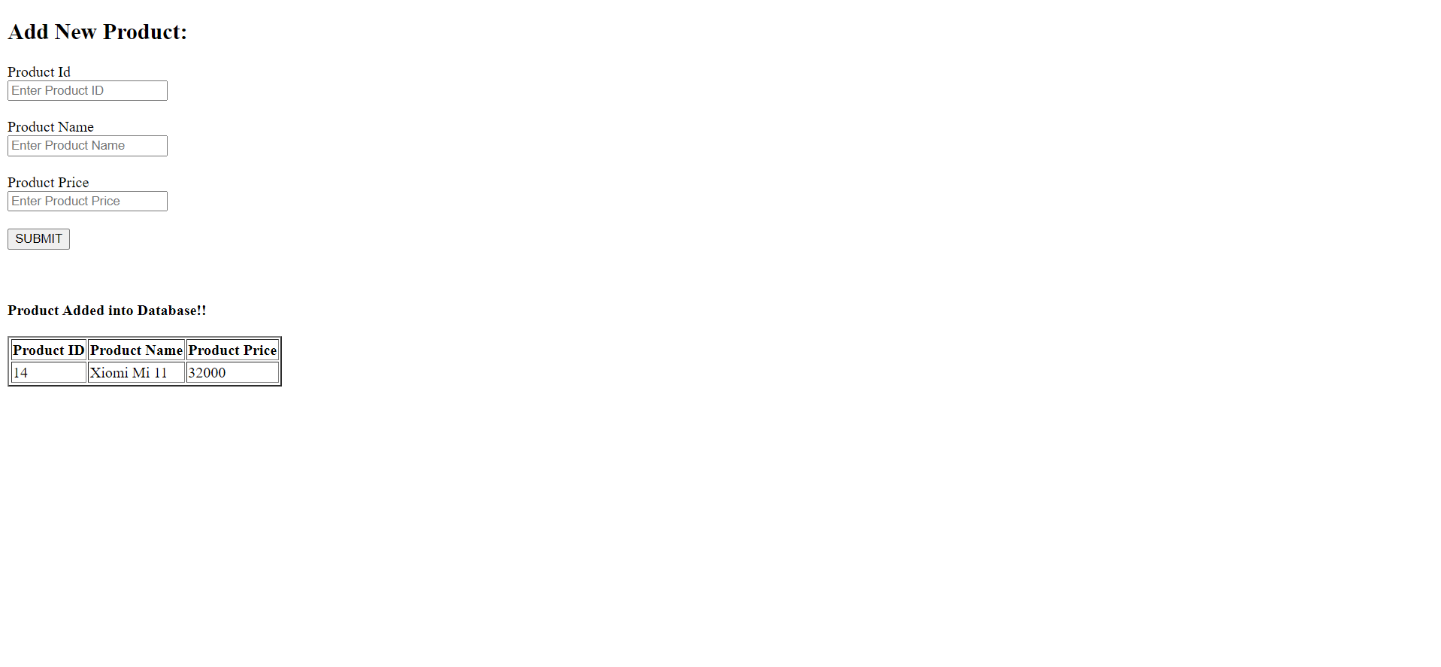

Output 2:

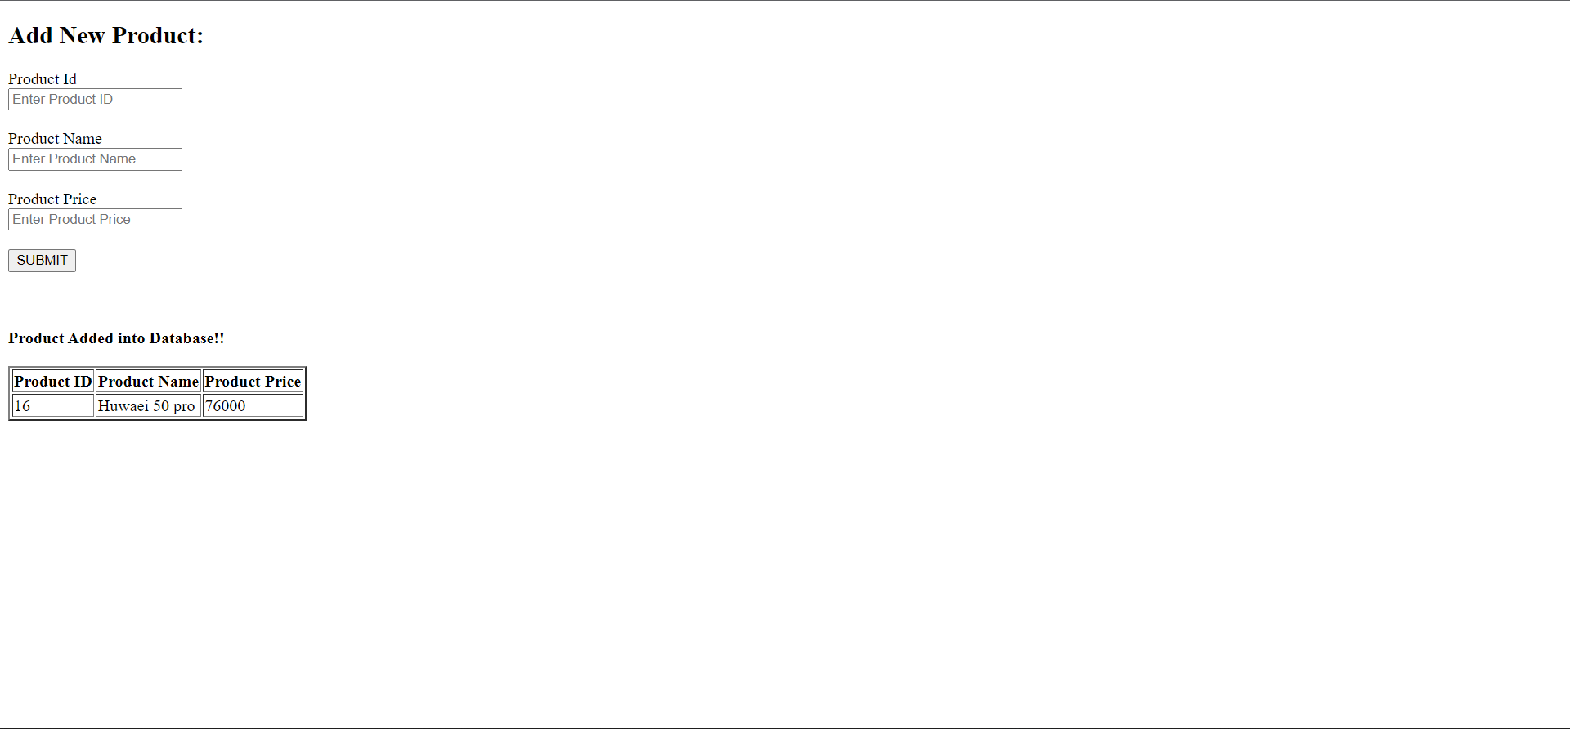

Git:

